

BS CYBER SECURITY PROGRAM, DEPARTMENT OF COMPUTER SCIENCE. HITEC UNIVERSITY TAXILLA.

***NAME: SYED ALI AHMED HASHMI***

***REG NO: 24-CyS-058***

***DEPARTMENT : CYBER SECURITY***

***SEC : A***

***COURSE : ARTIFICIAL INTELLIGENCE LAB***

***SUBMITTED TO : SIR MUBASHIR IQBAL***

***LAB REPORT : 03***

Q :1 Write a Python function to calculate the factorial of a number (a non- negative integer). The function accepts the number as an argument.

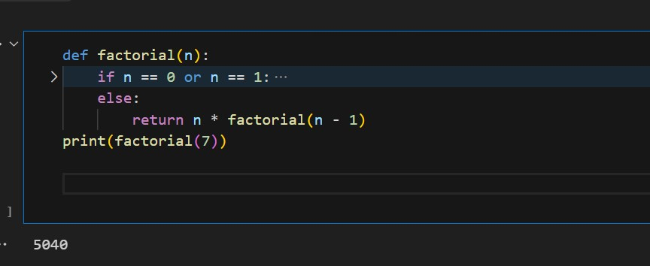

Q : 2 Write a Python function that takes a list and returns a new list with unique elements of the first list.

1. Sample List : [1,2,3,3,4,4,5,3,7,5]
2. Unique List:[1,2,3,4,5,7]

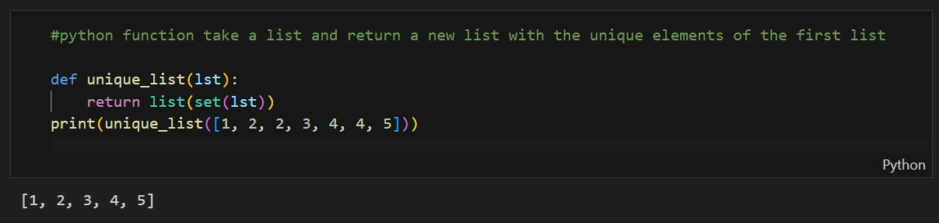

Q : 3 Write a Python function to show the first ‘n’ even numbers and then return the sum and product of that even numbers outside the function.

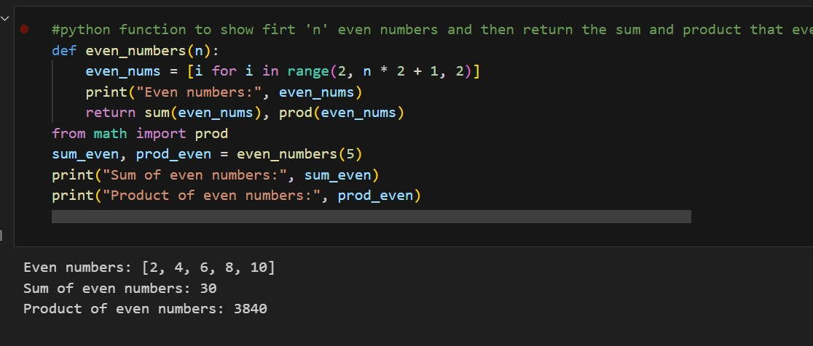

Q : 4 Write a python program to match two string using functions

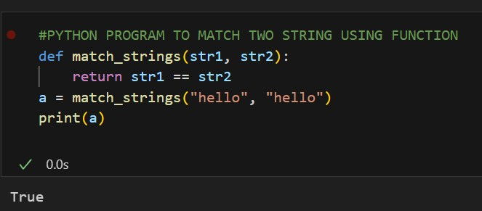

Q : 5 Write a python program to name user login system using function.

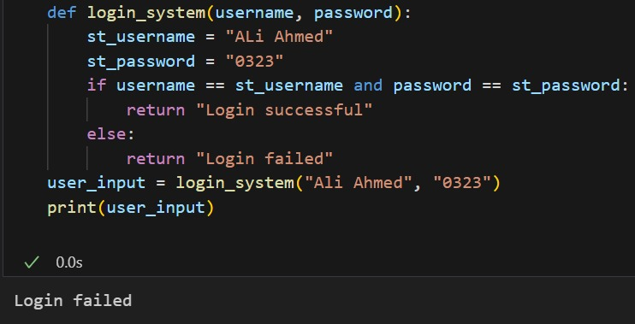

**CONCLUSION:**

In this lab, I learned how to create and use functions in Python. I understood how to pass arguments in different ways, use return values, and write simple programs using functions. Functions make the code easy to reuse, clean, and well organized. This lab improved my basic programming skills and helped me write better Python programs.

----------------------------------